Booklet 3.0: Living things in aquatic environments are affected by many factors.
Name: _______________________________ Class: __________
Section 3.1 (p.372-380)
- What is most of Earth’s surface covered in? (p.372)

Salt water - Oceans
- Some animals can live in both fresh and salt water environments, but most can only live in one or the other. Brainstorm ideas about what types of adaptations each animal would need. (p.372)
 | Salt Water | Both | Fresh Water
Organism Examples | 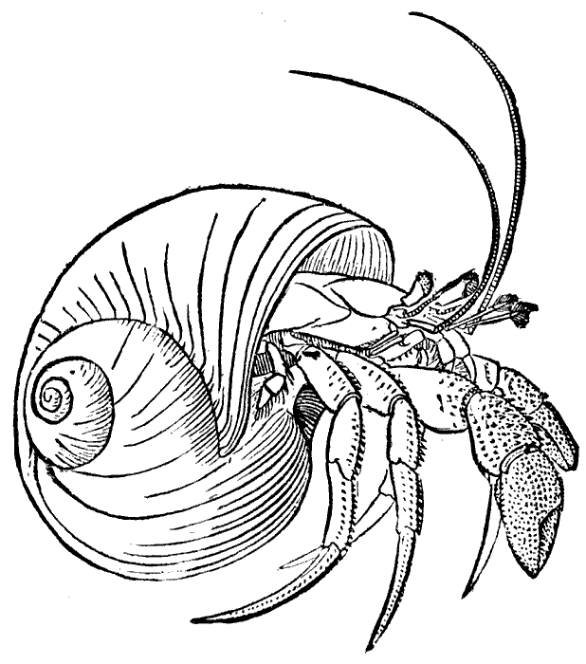hermit crab | 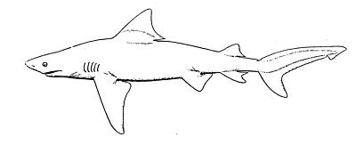  bull shark | 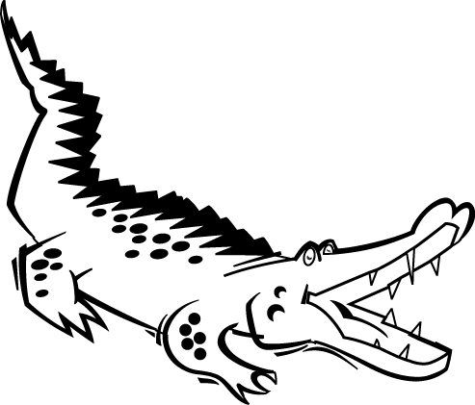alligator
Adaptations | Temperature  Salinity  Pressure  Water Movement | Salinity  Water Movement | Salinity  Water movement
- What are the 2 most diverse ecosystems on Earth? (p.373)

Tropical Rainforests and coral reefs

- Complete the statement: (p.373)
The more species in a pond, lake or river...
The more nutrients, light and oxygen you will find there.
- Define the words ecosystem and diversity. Then use both words together correctly in a single sentence. (p.374)

EcosystemWhere living things interact with other living and non-living things

DiversityRefers to the variety of different kinds of species living there

- The diagram below is similar to figure 3.3 (p.375). Please add point form notes from your textbook to make the diagram below more complete.

LAKE DIVERSIY

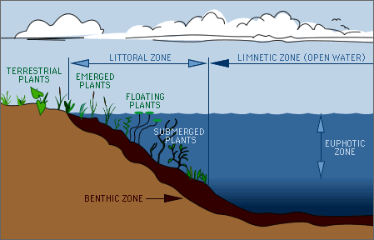

Upper Zone – lots of plants, all the light

Middle Zone – few plants, little light
Lowest Zone – no plants, big fish, no light

- The diagram below is similar to figure 3.4 (p.376-377). Please add point form notes from your textbook to make the diagram below more complete. Draw in the “estuary” portion of the diagram from your textbook. Try to guess what the “extra” labels on the diagram below mean.

OCEAN DIVERSIY

H2O movement adaptation Pressure adaptations
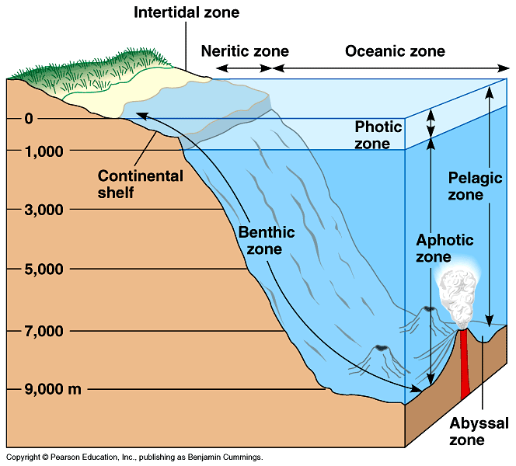

High pressure, low temp, no light adaptations

- Define adaptation. (p.378)
Physical characteristic or behavior of a species.

- Complete the chart below which shows different examples of Aquatic Environment Adaptations. (p.378-380)
Environmental Factor | Adaptation(s) and Example(s)
Temperature 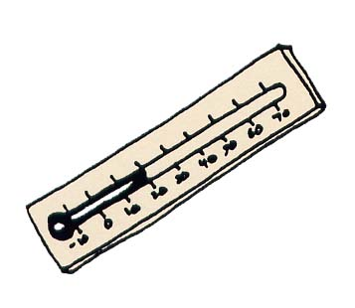 | They have to be adapted for hot and/or cold. If the temperature changes, they will not survive.
Light | Deeper in the ocean has no light, so fish have to be able to produce their own. (Bioluminescent)
Pressure  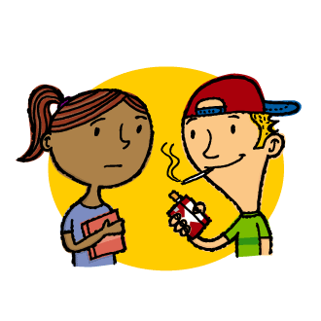  Just kidding! I don’t really mean “peer pressure”. | Deeper in the ocean, fish have to be able to deal with high pressure, would not survive in higher parts of the ocean.
Salinity  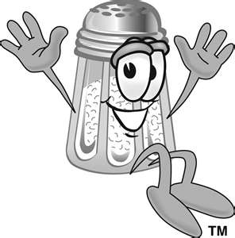 | Fresh or salt water fish deal with the salt differently.
H₂O Movement 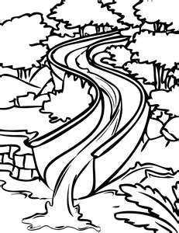 | Organisms in the intertidal zone have to deal with high and low tides.

- Why is the diversity of living things in salt water greater than in fresh water? Give as many reasons as you can think of.

-Larger bodies of salt water – can support more life
-Many different pressures – more variety of life can survive because the different species are adapted to live there

- What might happen to the fish in a lake if a factory discharged a large amount of hot water into the lake?
If the fish do not have the adaptations necessary to survive in both hot and cold water, then they will quickly die. (Thermal pollution)
Section 3.2 (p.381-385)
- 500 years ago, when John Cabot first arrived in the waters of Newfoundland he wrote that there were so many cod fish in the water that the boat had to slow down. He is also quoted as having said that the cod were so thick you could cross the water “walking on their backs”. Since then, something has happened to decrease cod numbers—they are now considered endangered! What do you think happened? (p.381) Over-hunted, decreasing in numbers
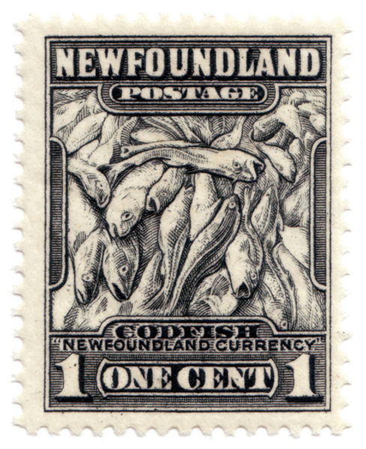
- What is a population? (p.381)
Group of organisms of the same species in a given area.
- Give 3 examples of population changes (not the major types of changes). (383)
Over-hunting, pesticides, famine, gender disparity, age disparity, pollution, war, infertility, new predator introduced.

- Define the 3 major types of changes in populations, and provide examples of each. (p.383)
Major type of seasonal change (definition) | Examples
Seasonal change:  The changes (increases and decreases) of populations during seasons. | *Extremes in temperature causes populations in increase and decrease (dying, hibernation)  *Migration
Short term change:  When cold to hot weather happens in a short amount of time, the populations will be affected | *Weather  *Mating  *extreme weather conditions
Long term change:  Changes in conditions that affect populations over a long period of time | *new species are introduced  *catastrophic natural disasters

- When populations or species die off, or when they’re unhealthy, it’s a sign that something in the ecosystem has changed, do you agree or disagree with this statement? Explain your reasons (support your answer).

Agree… ecosystems are in balance and are fragile. If you disrupt something, there could be effects to populations.
- How many populations do you see in the picture below? Support your answer.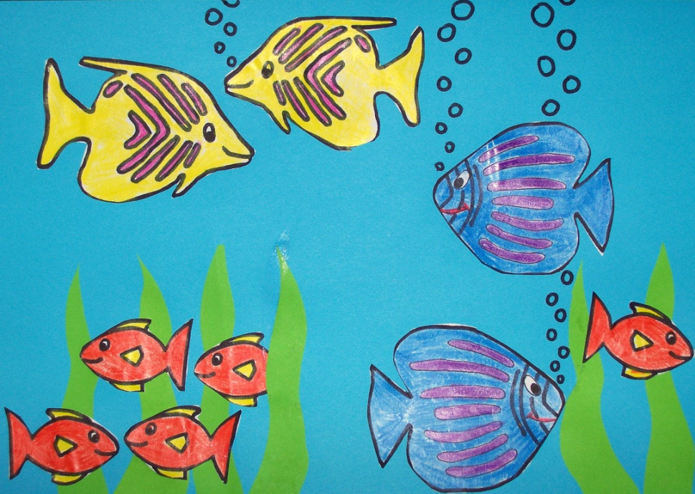 4

- The following table shows the cod catch off Canada’s east coast over 21 years.
Cod catch in tonnes
1972 | 1979 | 1988 | 1993
219,000 | 378,000 | 400,000 | 50,000

  - What trend do you see in the cod fishery over the years shown here?
Rose and dropped substantially
  - Why do you think this happened?
Over-fishing
  - From the information you have here (and what you already know...Hint: think of the video we watched earlier this year about the fishing industry), what do you predict has happened to the cod stocks since 1993?
Numbers have gone up because people are not allowed to fish anymore. (restricted)Section 3.3 (p.386-389)
- Read about Twin Lake in “Water Quality and Living Things” on page 386. Then answer the questions below.
  - What information would you need to investigate changes in the lake (decide if there is a problem or not)?
pH Sample, chemical sample, salinity measurement, odour test, bacteria measurement, observe population numbers, water level.
  - Where could you find this information?
Take samples and then test in a lab.

  - What kinds of professionals might you contact for further expertise?
Chemist, ecologist

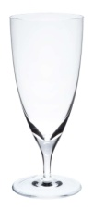
- All living things require water, but different organisms can survive on differing water qualities. Using page 386 –and your own ideas—write 4 examples supporting this statement.
Different adaptations
- What is an alkali lake? How does one form? How can it affect animal and plant life?
Water erodes rocks and dissolves chemicals which changes the pH of the lake.
- Are highly specialized species better or worse at adapting to changes in their environments? Why? (p.386)
Worse at adapting, because they have special requirements so they will not be able to change rapidly.
- Read page 388. List and explain 4 different examples of how water quality can change.
-pH level, salinity, O2 level, pollution.
- Acid rain affects the survival of young fish and the eggs and larvae of other aquatic organisms. It does not seem to affect the adults. How do you think acid rain would affect the growth of the fish populations over time?
Because it affects the young, the populations would live out and decrease substantially.

Booklet 4.0: Human activities affect aquatic environments.
Section 4.1 (p.392-399)
- Draw a labelled diagram showing the water cycle. (p.392)
Evaporation, Condensation, Precipitation, Run-off
- How do you use water? What are the benefits and costs of your water use?
Human Uses of Water
Water use | Benefits (+) | Costs (-)
Watering my lawn  Drinking  Water Fights  Cleaning  Cooking  Swimming  Surfing  Flushing the toilet  Ice | My lawn looks nice and I can enjoy my back yard  Basic Need (hydration)  Leisure (secondary grass watering) Don’t do it in the streets its dangerous and will cause industrial run-off)  Humans smell  Kill bacteria | I sometimes forget to turn off the sprinkler and waste water; it ends up going down the drain unused  Wasting water  Wasting Water  Wasting water, causing pollution

- Use pages 394-395 to complete a summary of our 3 major uses of water (as humans).

AGRICULTURE
73% of water is used for irrigation
Provides food and jobs (economical reason)
If you have too much water, you cause salts to dissolve in the water

22% industry
You can use water to cool you machines
You use water as a solvent
Plastics use the most water

Only 5% is used in homes

DOMESTIC

- What are the advantages and disadvantages of using Dams to manage our water? Please use an organizational chart (of your choice) to manage your notes (p.396)

Advantages Disadvantages
Can prevent flooding Kills habitats
Hydroelectricity Water flow
Employment Migration
Recreation Sedimentation
Irrigation
Shipping (through locks)

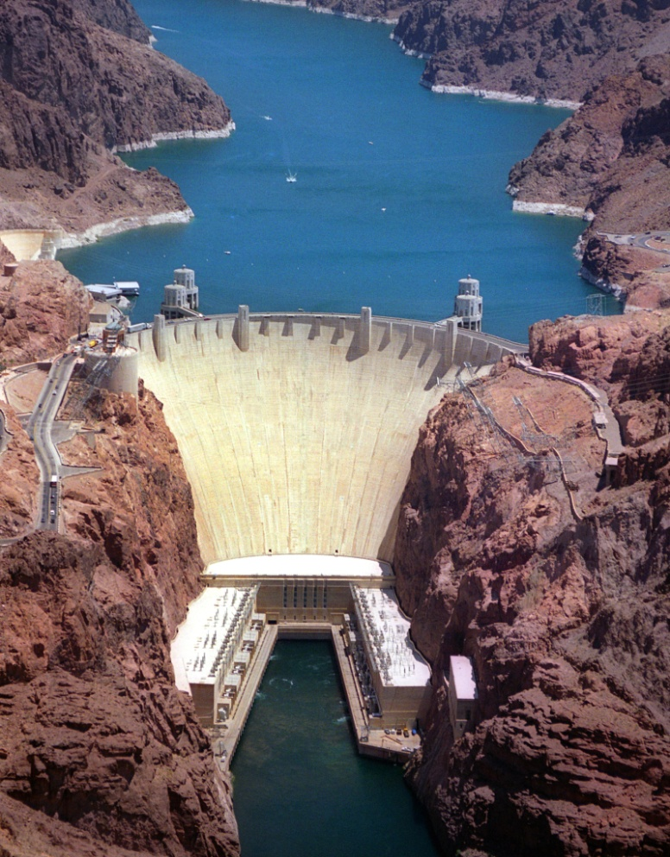
- Name 6 facts about Canadian dams. (p.396)

- Canada is one of the top 10 dam builders
- Most river systems in Canada are dammed
- We have over 600 large dams, and thousands of smaller ones
- Most Canadian dams are for hydroelectricity
- Rain water and water from melting snow can be captured
- Most of Canada’s dams are in QC and BC.
- Copy a simplified version of figure 4.13 into the space below. In point form, explain the different human-activities that affect water systems and water quality.

Section 4.2 (p.400-404)
- Give 2 examples of how scientists monitor water quality. (p.400)

- What is Giardia? (p.400)

- What does it mean when we say we monitor our drinking water in Calgary? (p.400-401)

- Though science and technology have helped us a lot throughout time, true problem solving requires something else. What is it? Give an example to support your answer. (p.403)

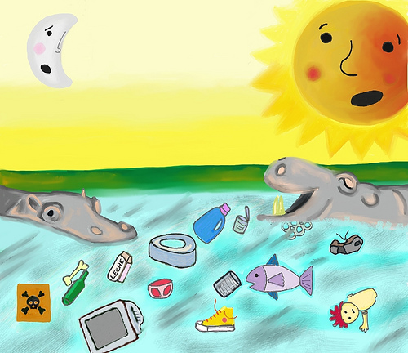

CONGRATULATIONS! YOU ARE FINISHED THE LAST BOOKLET FOR GRADE 8 SCIENCE!!!
Please use any extra time you have to review this chapter prior to the final unit 5 test. Try solving questions 1-25 on pages 410-412.

If you are feeling like you would rather review for our year end final, look at the Unit Review questions at the end of each unit we have completed this year. You can also begin reviewing your booklets from throughout the year.

