The RESPIRATORY System

The respiratory system functions to supply blood with Oxygen and remove Carbon Dioxide from you blood, returning it to the air outside your body. There are 2 major processes to this system:

BREATHING vs. RESPIRATION
|
|
|
|
|
|
|
|
|
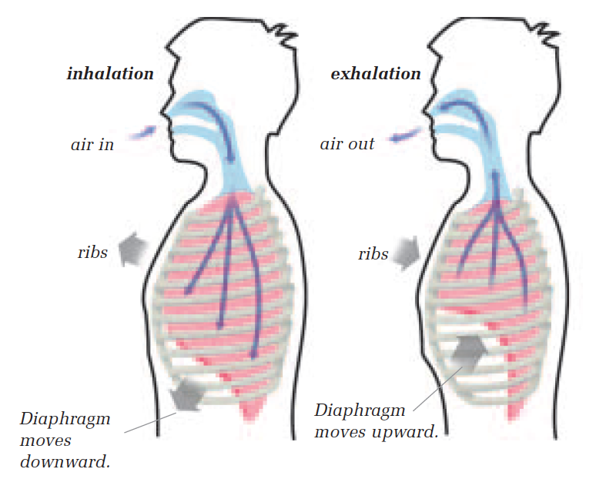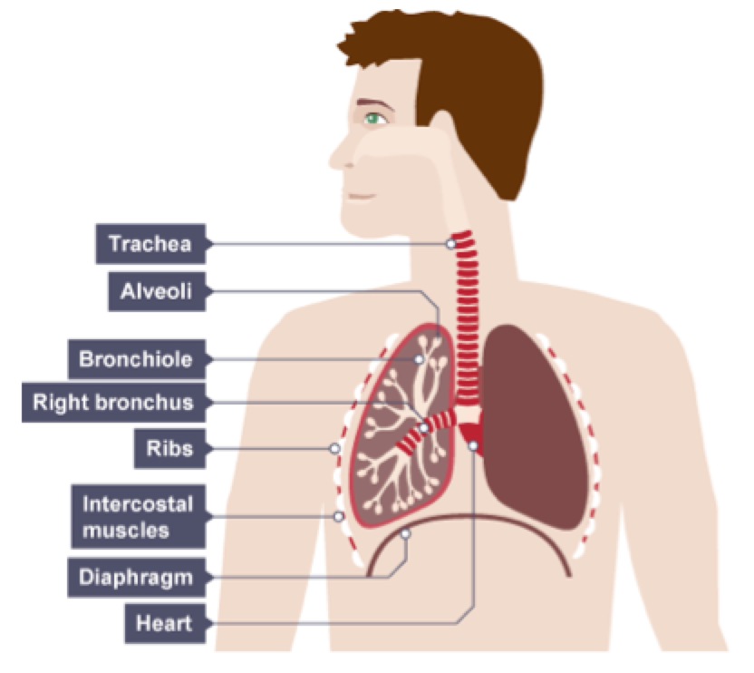

The respiratory system draws oxygen-rich air into the lungs through a series of tube-like passageways called bronchi. These bronchi narrow to bronchioles that end in about 600 000 000 tiny, air-filled sacs called alveoli. The alveoli are surrounded by capillaries, which are responsible for diffusing oxygen and carbon dioxide in and out of the blood. It takes only one second for blood to travel through your lungs, picking up as much oxygen as it can hold and releasing its carbon dioxide waste.

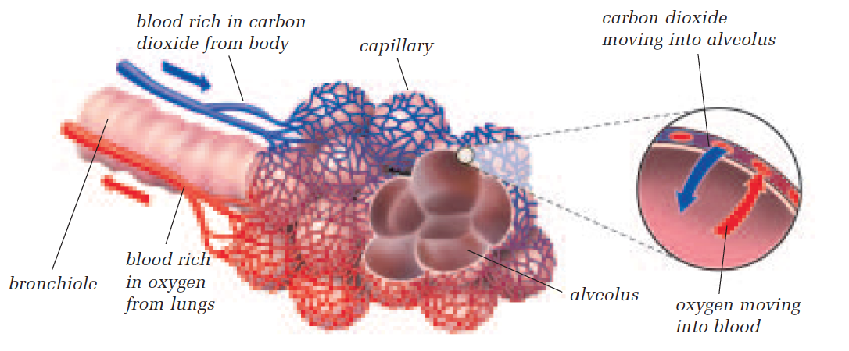
TedED: How Oxygen Travels Through your Body
As you watch the TedED lesson on the respiratory system, answer the questions below:

- Approximately how many times do you breathe in every day? _____________
- What is the process called that uses oxygen and results in the production of the ATP we use as energy? _____________________________
- The level of red blood cells in the blood is regulated by which organ(s)? ______________________
- To ensure sufficient oxygen diffusion, the lungs contain hundreds of millions of miniature balloon-like projections. This increases the lungs’ surface area to approximately how many square meters? _____________
- Which of the following are necessary for oxygen to reach the cells of your body: the nervous, muscular, circulatory, respiratory, skeletal system, or all of the above? _________________________
- If all these major organ systems need to work together to achieve oxygen delivery, in what ways could the process of oxygen transportation from air to cell be positively influenced by the choices we make and the actions we take?

QUICK REVIEW NEXT DAY
